VOLUNTEERS POLICY
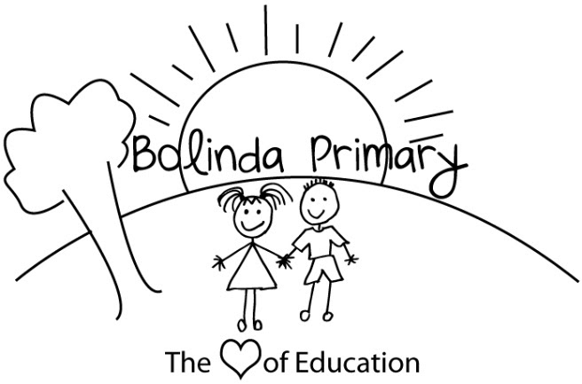
PURPOSE
To outline the processes that Bolinda Primary School will follow to recruit, screen, supervise and manage volunteers to provide a child safe environment, and to explain the legal rights of volunteers.

SCOPE
This policy applies to the recruitment, screening, supervision and management of all people who volunteer at our school.

DEFINITIONS
Child-related work: work that usually involves direct contact (including in person, over the phone, written and online communication) with a child that is a central part of that person’s duties. It does not include work that involves occasional contact with children that is incidental to the work.
Closely related family member: parent, carer, parent/carer’s spouse or domestic partner, stepparent, parent/carer’s mother or father in-law, grandparent, uncle or aunt, brother or sister, including step or half siblings.
Volunteer worker: A volunteer school worker is a person who voluntarily engages in school work or approved community work without payment or reward.
School work: School work means:
- Carrying out the functions of a school council
- Any activity carried out for the welfare of a school, by the school council, any parents’ club or association or any other body organised to promote the welfare of the school
- Any activity carried out for the welfare of the school at the request of the principal or school council
- Providing assistance in the work of any school or kindergarten
- Attending meetings in relation to government schools convened by any organisation which receives government financial support
This is a broad definition and means that volunteers who participate in school community activities, such as fundraising and assisting with excursions, are legally protected (ie indemnified) from action by others in the event of an injury or accident whilst they are performing volunteer school work in good faith.

POLICY
Bolinda Primary School is committed to implementing and following practices which protect the safety and wellbeing of children and our staff and volunteers. Bolinda Primary School also recognises the valuable contribution that volunteers provide to our school community and the work that we do.
The procedures set out below are designed to ensure that Bolinda Primary School’s volunteers are suitable to work with children and are well-placed to make a positive contribution to our school community.

Becoming a volunteer
Members of our school community who would like to volunteer are encouraged to talk to their classroom teacher or email the Principal.

Suitability checks including Working with Children Checks
Working with students
Bolinda Primary School values the many volunteers that assist in our classrooms, with sports events, camps, excursions, school concerts, and other events and programs. To ensure that we are meeting our legal obligations under the Working With Children Act 2005 (Vic) and the Child Safe Standards, Bolinda Primary School is required to undertake suitability checks which may include a Working With Children Check (WWC), proof of identity, work history involving children and/or reference checks.
Considering our legal obligations, and our commitment to ensuring that Bolinda Primary School is a child safe environment, we will require volunteers to obtain a WWC Check and produce their valid card to the school office for verification in the following circumstances:
- Parent/family volunteers and volunteers who are not parent/family members of any student at the school are required to have a WWC Check if they are assisting with any school activities (including classroom activities, excursions, camps and similar events) regardless of whether they are supervised or not, or whether the volunteer’s child is participating or not.
- Parent/community School Council members sitting on School Council with student School Council members, regardless of whether their own child is a student member or not.
In addition, depending on the nature of the volunteer work, our school may ask the volunteer to provide other suitability checks at its discretion (for example, references, work history involving children and/or qualifications). Proof of identity may also be required in some circumstances.
Non child-related work
On some occasions, parents and other members of the school community may volunteer to do work that is not child-related. For example, volunteering on the weekend for gardening, maintenance, or working bees, school council, participating in sub-committees of school council, fundraising event coordination, or other fundraising groups that meet in the evenings during which children will not be, or would not reasonably be expected to be, present.
At Bolinda Primary School, volunteers for this type of work will still be required to provide a valid WWC Check.
School council members and volunteers on any sub-committee of school council will be asked to provide a valid WWC Check. Whilst we acknowledge that these volunteers will not be engaging in child-related work as part of their role, even when there is a student sitting on the school council, we believe that it is important that our volunteers who are involved in making important decisions about our school which will have an impact on students do have a valid WWC Check.

Management and supervision
All volunteers are required to sign in at the school office at the beginning of each day’s volunteering. All volunteers are also required to sign out at the school office at the end of each day’s volunteering.
Volunteer workers will be expected to comply with any reasonable direction of the principal (or their nominee). This will include the requirement to follow our school’s policies, including, but not limited to our Child Safety Policy, our Child Safe Standards Code of Conduct and our Statement of Values and School Philosophy. Volunteer workers will also be expected to act consistently with Department of Education and Training policies, to the extent that they apply to volunteer workers, including the Department’s policies relating to Equal Opportunity and Anti-Discrimination, Sexual Harassment and Workplace Bullying.
The principal has the discretion to make a decision about the ongoing suitability of a volunteer worker and may determine at any time whether or not a person is suitable to volunteer at Bolinda Primary School.
Bolinda Primary School will provide any appropriate induction and/or training for all volunteer workers. The principal (or their nominee) will determine what induction and/or training is necessary depending on what type of work the volunteer will be engaged in.
All volunteers will be provided induction in relation to Bolinda Primary School’s child safety practices, including reporting obligations and procedures. Our school has a Child Safety Responding and Reporting Obligations (Including Mandatory Reporting) Policy and Procedures which all staff and volunteers should be aware of.
The principal (or their nominee) will determine what supervision, if any, of volunteers is required for the type of work being performed.

Compensation
Personal injury
Volunteer workers are covered by the Department of Education and Training’s Workers Compensation Policy if they suffer personal injury in the course of engaging in school work.
Property damage
If a volunteer worker suffers damage to their property in the course of carrying out school work, the Minister (or delegate) may authorise such compensation as they consider reasonable in the circumstances. Claims of this nature should be directed to the principal who will direct them to the Department’s Legal Division.
Public liability insurance
The Department of Education and Training’s public liability insurance policy applies when a volunteer worker engaged in school work is legally liable for:
- a claim for bodily injury to a third party
- damage to or the destruction of a third party’s property.

RELATED POLICIES AND RESOURCES
- Statement of Values and School Philosophy Policy
- Visitors to Bolinda Primary School Policy
- Child Safe Standards Policy

REVIEW CYCLE
This policy was last approved by school council on 30 September 2020 and is scheduled for review in September 2023.

This document is a department of education template.

