CHILD SAFE STANDARD
CODE OF CONDUCT
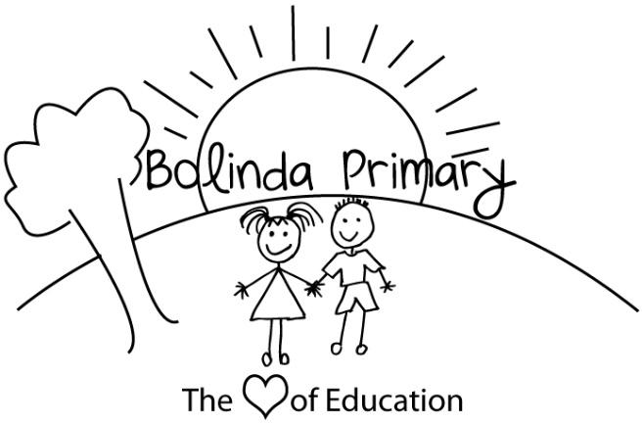

Bolinda Primary School is committed to the safety and wellbeing of children and young people. Our school community recognises the importance of, and a responsibility for, ensuring our school is a safe, supportive and enriching environment which respects and fosters the dignity and self-esteem of children and young people, and enables them to thrive in their learning and development.

This Code of Conduct aims to protect children and reduce any opportunities for child abuse or harm to occur. It also assists in understanding how to avoid or better manage risky behaviours and situations. It is intended to complement child protection legislation, Department policy, school policies and procedures and professional standards, codes or ethics as these apply to staff and other personnel.

The Principal and school leaders of Bolinda Primary School will support implementation and monitoring of the Code of Conduct, and will plan, implement and monitor arrangements to provide inclusive, safe and orderly schools and other learning environments. The Principal and school leaders of Bolinda Primary School will also provide information and support to enable the Code of Conduct to operate effectively.

All staff, contractors, volunteers and any other members of the school community involved in child-related work are required to comply with the Code of Conduct by observing expectations for appropriate behaviour below. The Code of Conduct applies in all school situations, including school camps and in the use of digital technology and social media.

Acceptable behaviours
As staff, volunteers, contractors, and any other member of the school community involved in child-related work individually, we are responsible for supporting and promoting the safety of children by:
- upholding the school’s statement of commitment to child safety at all times and adhering to the school’s child safe policy
- treating students and families in the school community with respect both within the school environment and outside the school environment as part of normal social and community activities
- listening and responding to the views and concerns of students, particularly if they are telling you that they or another child has been abused or that they are worried about their safety/the safety of another child
- promoting the cultural safety, participation and empowerment of Aboriginal and Torres Strait Islander students
- promoting the cultural safety, participation and empowerment of students with culturally and/or linguistically diverse backgrounds
- promoting the safety, participation and empowerment of students with a disability
- reporting any allegations of child abuse or other child safety concerns to the school’s principal
- understanding and complying with all reporting or disclosure obligations (including mandatory reporting) as they relate to protecting children from harm or abuse.
- if child abuse is suspected, ensuring as quickly as possible that the student(s) are safe and protected from harm.

Unacceptable behaviours
As staff, volunteers, contractors, and any other member of the school community involved in child-related work, we must not:
- ignore or disregard any concerns, suspicions or disclosures of child abuse
- develop a relationship with any student that could be seen as favouritism or amount to ‘grooming’ behaviour (for example, offering gifts)
- exhibit behaviours or engage in activities with students which may be interpreted as abusive and not justified by the educational, therapeutic, or service delivery context
- ignore behaviours by other adults towards students when they appear to be overly familiar or inappropriate
- discuss content of an intimate nature or use sexual innuendo with students, except where it occurs relevantly in the context of parental guidance, delivering the education curriculum or a therapeutic setting
- treat a child unfavourably because of their disability, age, gender, race, culture, vulnerability, sexuality or ethnicity.
- communicate directly with a student through personal or private contact channels (including by social media, email, instant messaging, texting etc) except where that communication is reasonable in all the circumstances, related to school work or extra-curricular activities or where there is a safety concern or other urgent matter
- photograph or video a child in a school environment except in accordance with school policy or where required for duty of care purposes
- in the school environment or at other school events where students are present, consume alcohol contrary to school policy or take illicit drugs under any circumstances.

This Code of Conduct was approved by the Bolinda Primary School Council on 24th November for review if legislative or other changes require in the interim or no later than December 2022.

SPAG: http://www.education.vic.gov.au/school/principals/spag/safety/pages/photoandfilm.aspx . The policy says the school should get consent before taking and publishing photos of a student. This applies every time a photo is taken. The same policy applies for excursions and school activities.
SPAG: http://www.education.vic.gov.au/school/principals/spag/safety/pages/alcohol.aspx. The policy says the school must obtain school council approval before alcohol can be consumed on school grounds or at a school activity. The policy says staff members should not consume alcohol during camps and excursions. It is silent on whether they can consume alcohol at other school events where students are present, this is a matter that the school will decide upon on a case-by-case basis.

