VISITORS POLICY
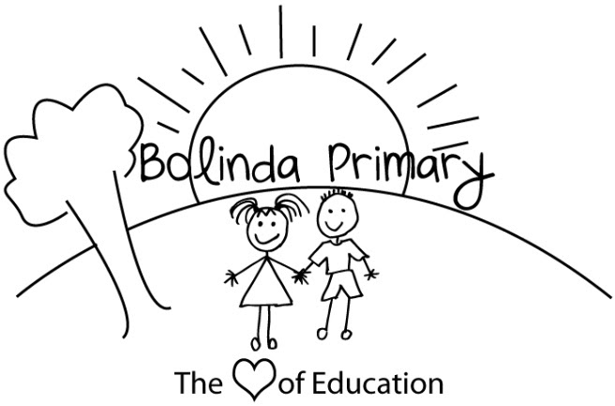

PURPOSE
To provide a safe and secure learning and teaching environment for students and staff by establishing processes to monitor and manage visitors to Bolinda Primary School.

SCOPE
This policy applies to any visitors who may attend school grounds when the school is open for instruction between the hours of 8:45am and 3:45pm. Outside of these times, our front office is not staffed and the only visitors who are permitted on school grounds are parents/carers or their delegates who are dropping off or picking up students from Outside School Hours Care, school events such as parent teacher interviews, concerts, sport or other school activities, and community and other groups who have entered into contracts or agreements with the school to use school premises outside of school hours.

DEFINITIONS
Child-related work: As defined by the Working with Children Act 2005 (Vic), child-related work is work that usually involves direct contact (including in person, over the phone, written and online communication) with a child that is a central part of that person’s duties. It does not include work that involves occasional contact with children that is incidental to the work.

POLICY
Bolinda Primary School strives to create an open and inclusive school community, and encourages parents and carers to be actively involved in their child’s development and education. We also strive to foster strong partnerships with local community services, schools and other organisations.
Bolinda Primary School is not a public place. The principal has the authority to permit or deny entry to school grounds, and encourages all visitors to familiarise themselves with our school’s Statement of Values and School Philosophy, and Child Safe Standard Code of Conduct.
From time to time, different members of the public may visit our school. Visitors may include, but are not limited to:
- Parents
- Volunteers – see our school’s Volunteers Policy for more information
- Prospective parents, students and employees
- Invited speakers, sessional instructors and others addressing learning and development
- Public officials (eg Members of Parliament, local councillors)
- Persons conducting business eg: uniform suppliers, booksellers, official school photographers, commercial salespeople
- Tradespeople
- Children’s services agencies
- Talent scouts
- Department of Health and Human Services workers
- Victoria Police
- Persons authorised to enter school premises (eg Worksafe inspectors, health officers etc)
- Other Department of Education and Training staff (including allied health staff) or contractors
- NDIS therapists or other allied health or health practitioners
Sign in procedure
All visitors to Bolinda Primary School are required to report to the school office on arrival (see exceptions below in relation to parents/carers). Visitors must:
- Record their name, signature, date and time of visit and purpose of visit in our computer system, accessible on the tablet computer in the office, or on the sign in sheet if the tablet computer is unavailable
- Provide proof of identification to office staff upon request
- Produce their valid Working with Children Check where required by this policy (see below)
- Follow instruction from school staff and abide by all relevant policies relating to appropriate conduct on school grounds including Child Safe Standards Code of Conduct, Sexual Harassment Policy, Workplace Bullying Policy, Statement of Values and School Philosophy Policy
- Return to the office upon departure and sign out.
Bolinda Primary School will ensure that our school’s Child Safe Standards Code of Conduct is available and visible to visitors when they sign in.
Requirements for visitors to produce a valid Working with Children Check card
For Working with Children Check (WWC Check) and other suitability check requirements relating to parents/carers and other volunteers working with students please see our Volunteers Policy.
All visitors who are engaged in child-related work (see definition above) must have a valid WWC Check.
In some circumstances, visitors to Bolinda Primary School who are not engaged in child-related work will also be required to produce a valid WWC Check depending on the particular circumstances of their visit. For example, Bolinda Primary School will require a valid WWC Check for:
- visitors who will be working regularly with children during the time they are visiting, even though direct contact with children is not a central part of their normal duties
- visitors (e.g. contractors), who will regularly be performing work at the school and in circumstances where they will be performing their work in an area where they will be unsupervised and around children.
Further background checks, including references, may also be requested at the discretion of the principal.
Visitors who will be working in areas away from students (e.g. a visiting auditor who will be located in the front office with administration staff) or who will be supervised and accompanied by a staff member during their visit (e.g. a Member of Parliament, a journalist, a prospective parent on a school tour) will not be required to have a WWC Check.
Sworn Victoria Police officers or sworn Australian Federal Police officers are exempt from requiring a WWC Check, but may be asked to verify that they are sworn officers by providing proof of identification.
Invited speakers and presenters
On occasion, Bolinda Primary School may invite external speakers or providers to deliver incursions, presentations, workshops and special programs for our students. Consistent with Department of Education and Training requirements, Bolinda Primary School will:
- ensure that the content of presentations and programs by external providers contributes to the educational development of our students and is consistent with curriculum objectives
- ensure that any proposed visit, programs or content delivered by visitors complies with the requirement that education in Victorian government schools is secular and is consistent with the values of public education, Department policies and the Education and Training Reform Act 2006 (Vic). In particular, programs delivered by visitors are to be delivered in a manner that supports and promotes the principles and practice of Australian democracy including a commitment to:
  - elected government
  - the rule of law
  - equal rights for all before the law
  - freedom of religion, speech and association
  - the values of openness and tolerance
  - respect the range of views held by students and their families.

Parent visitors
We understand that there may occasionally be a reason why a parent or carer may want to speak to or see their child at school, during school hours.
If there is a particular pressing or unavoidable issue that cannot wait until the end of the school day, we ask that parents or carers call the school office to make the request to speak to or see their child during school hours.
We also ask that parents avoid arranging to visit their children at school wherever possible, as this can cause inappropriate disruptions to the school day.
All parents or carers who visit our school during school hours, other than for the purposes of school pick ups and drop offs or for specific school events (eg parent teacher interviews, concerts, assemblies etc), are required to sign in as a visitor at the school office.
Other visitors
All business operators, tradespeople and other visitors attending the school to conduct work must report to the school office upon arrival for instruction and follow the sign in procedure outlined above.

RELATED POLICIES AND RESOURCES
- Statement of Values and School Philosophy Policy
- Volunteers Policy
- Child Safety Policy
- Child Safe Standard Code of Conduct

REVIEW PERIOD
This policy was last updated on 9 October 2020 and is scheduled for review in October 2023.

This document is a department of education template.

